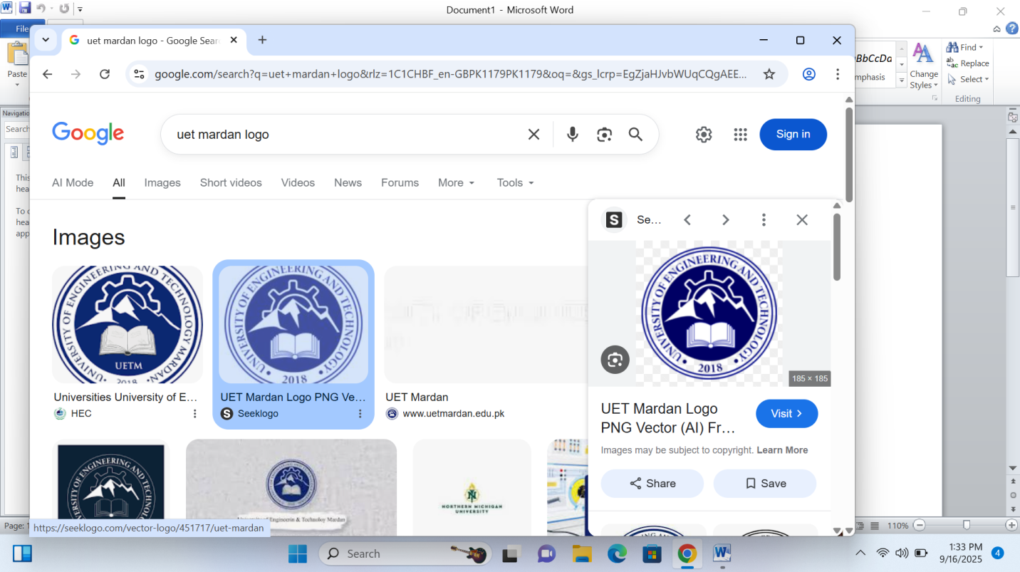

Department Of Computer Software Engineering

Submitted To: Sir Nouman Sajid

Submitted By: Khudija

Reg No: 25MDSWE433

Batch No: 08

Subject: ICT

Open Ended Lab

Website Objective:

Primary Objective:
“To develop a comprehensive personal portfolio website using html that authentically represents my identity as Khudija Zahoor , a first-semester Computer Software Engineering student at UET Mardan. This website serves as a digital introduction to my academic journey demonstrates my commitment to learning programming and emerging technologies and establishes my professional online presence as a work toward my career goal of becoming a successful programmer”.

Specific Objective:

Personal Introduction:
To introduction myself (Khudija Zahoor) and present my educational background to visitor in an engaging and professional manner.

Showcase My Journey:
To share my academic path at UET Mardan including my program details, current semester and commitment to learning software engineering.

Highlight My Passion:
To demonstrate my enthusiasm for programming innovation problem solving and continuous learning in the field of technology.

Express Career Goals:
To clearly communicate my future aspiration of becoming a successful programming staying update with emerging technologies and making a positive impact through code.

Public Github Link:
https://github.com/khudijazahoor321-dot/Information-and-Communication-Technology
Html Tags Used:

Core Tags:
<!DOCTYPE html>
<html>
<head>
<mata>
<title>
<style>
<body>

Semantic tags:
<nav>
<section>
<footer>

Container Tags:
<div>

Heading Tags:
<h1>
<h2>
<h3>
<h4>
Content Tags:
<p>
<ul>
<li>
<a>

Code:
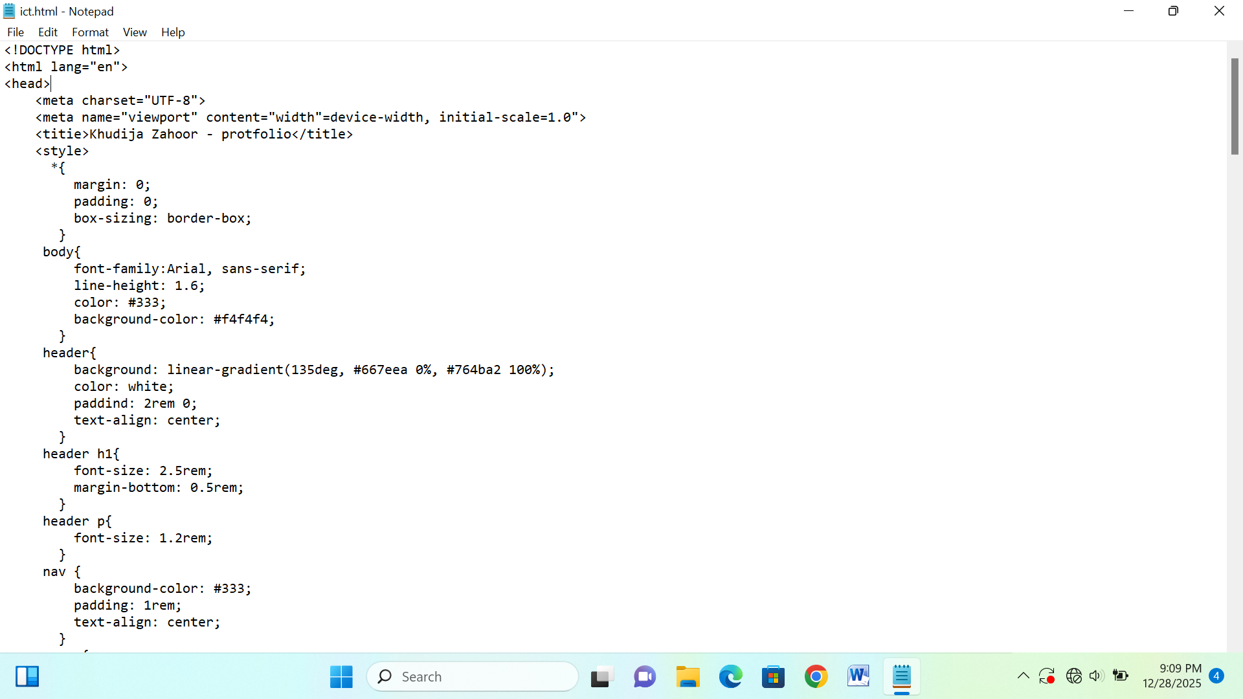
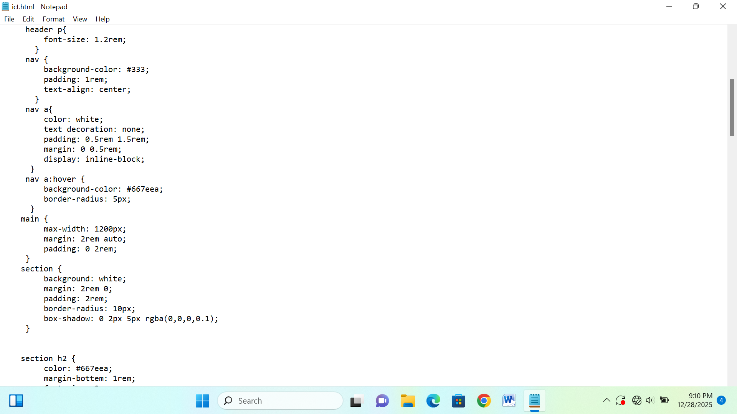
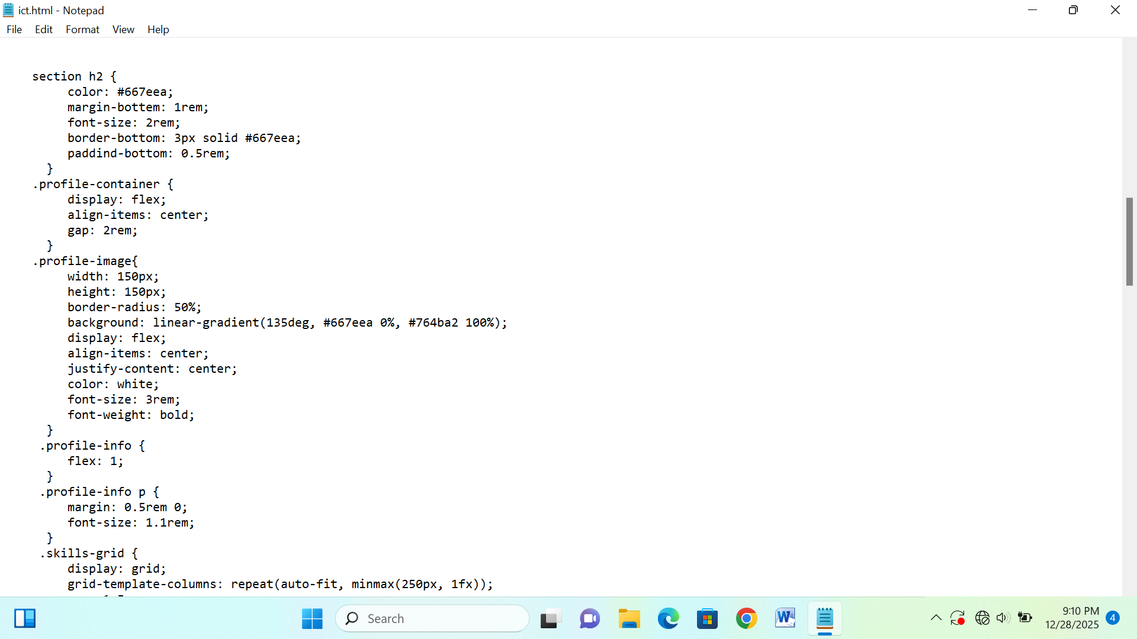
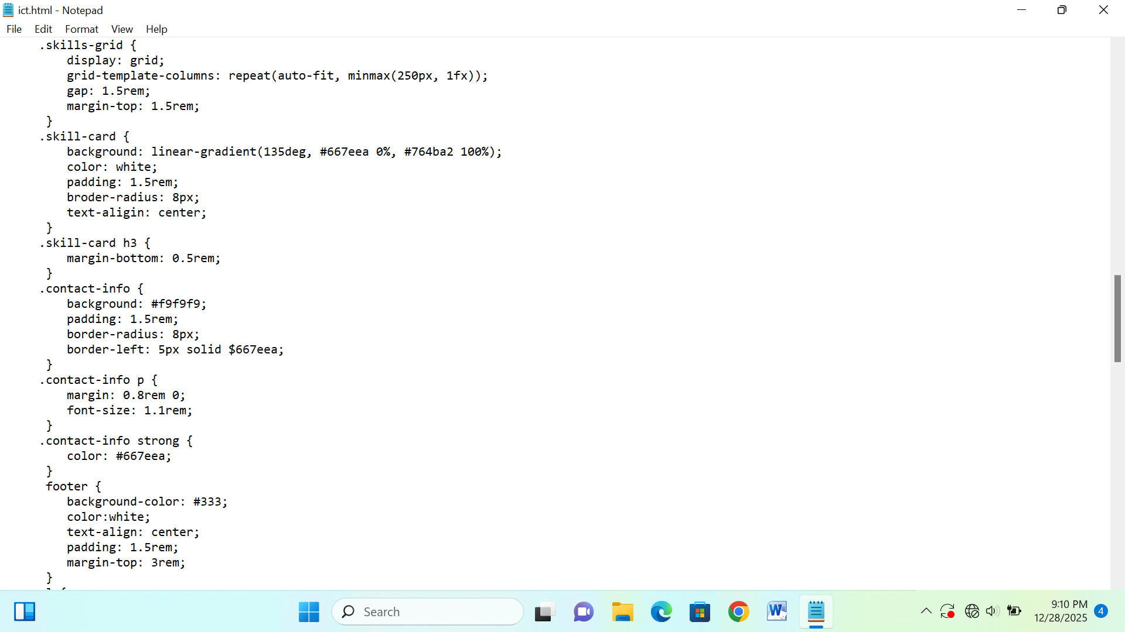
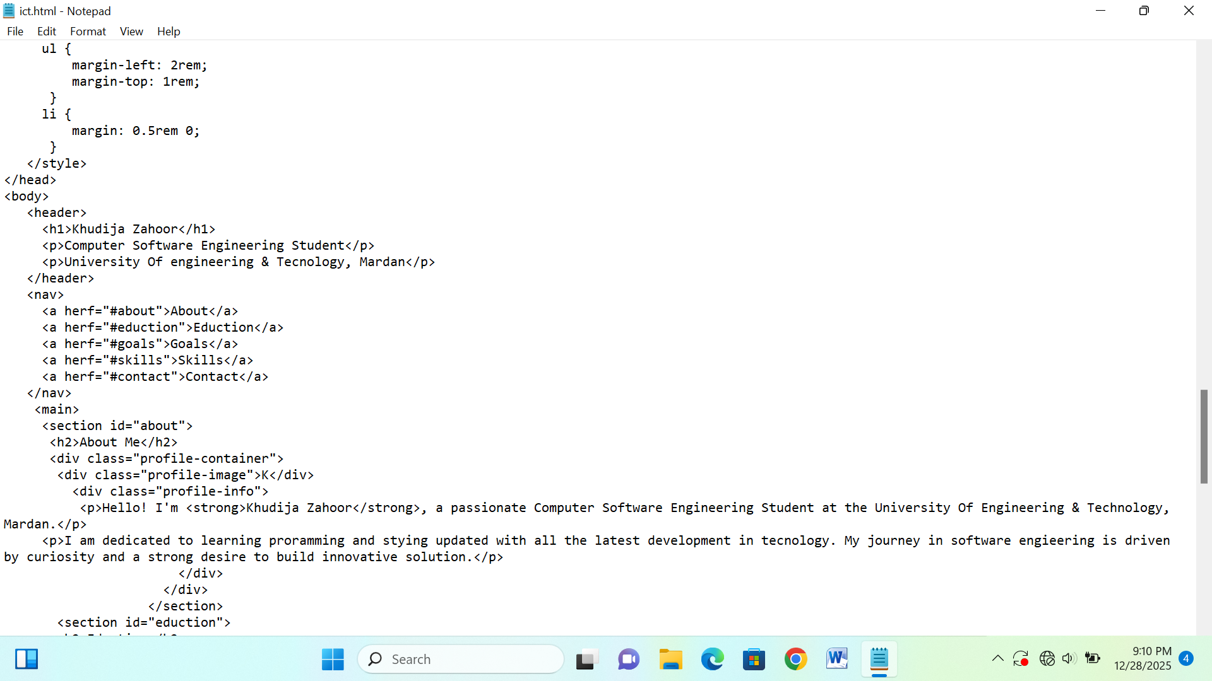
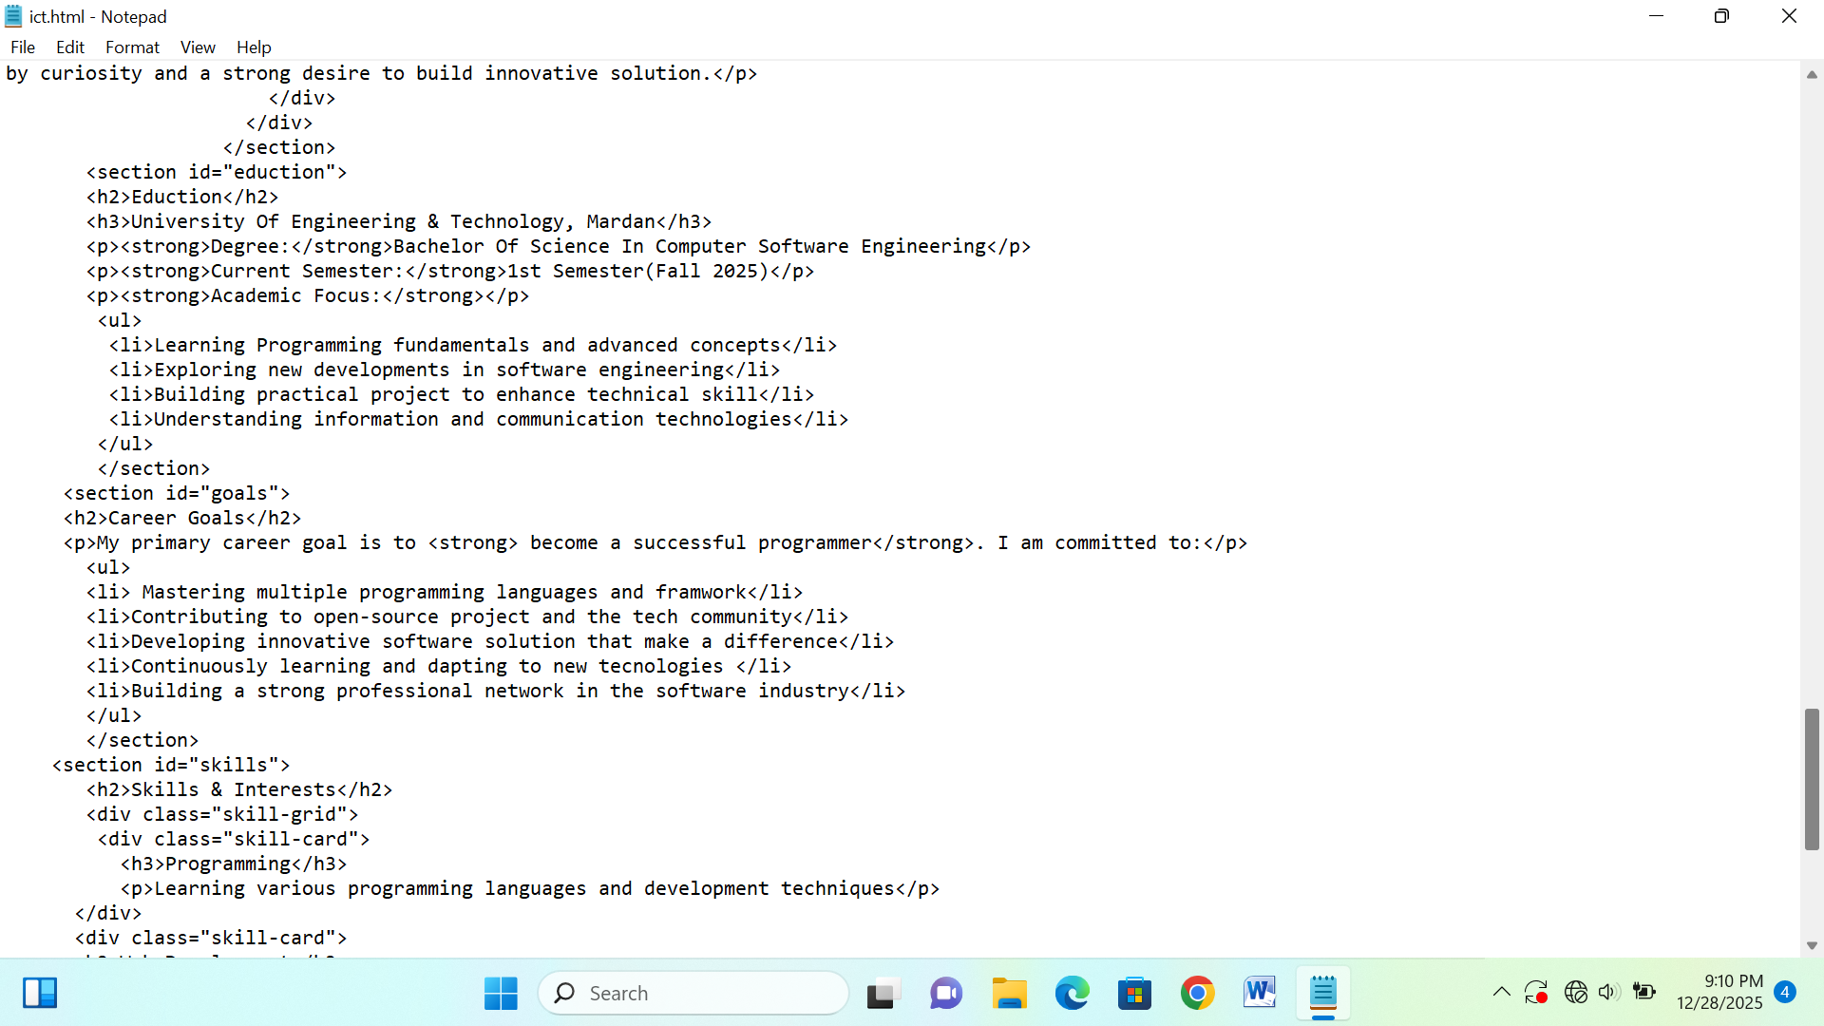
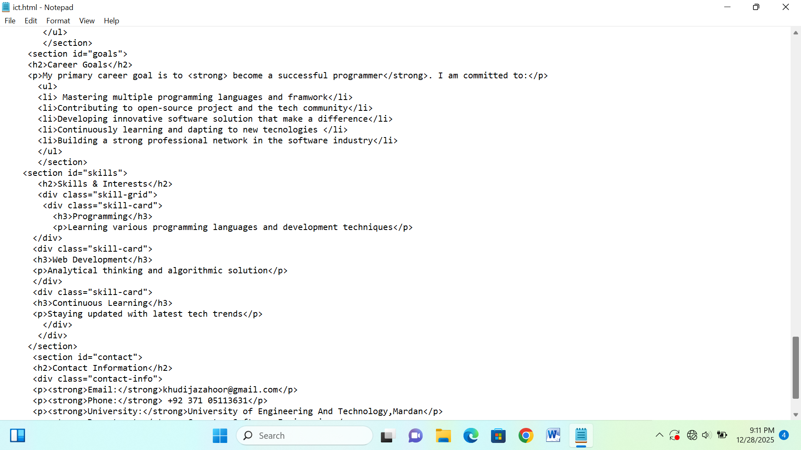
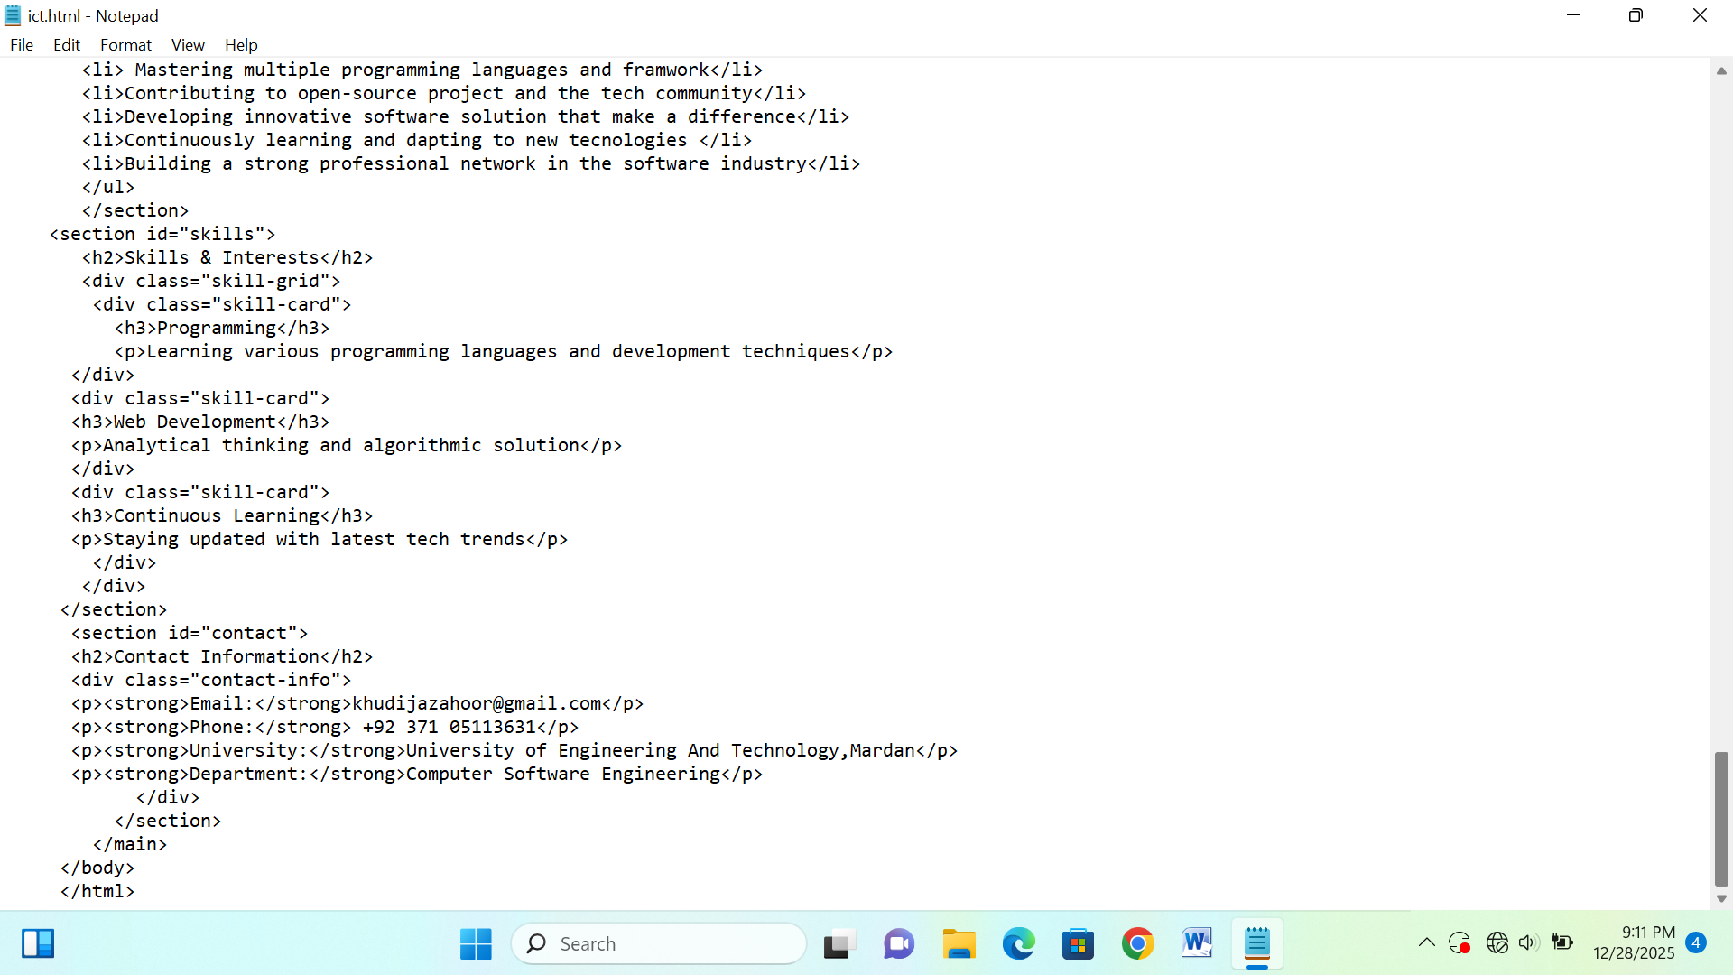

Output:
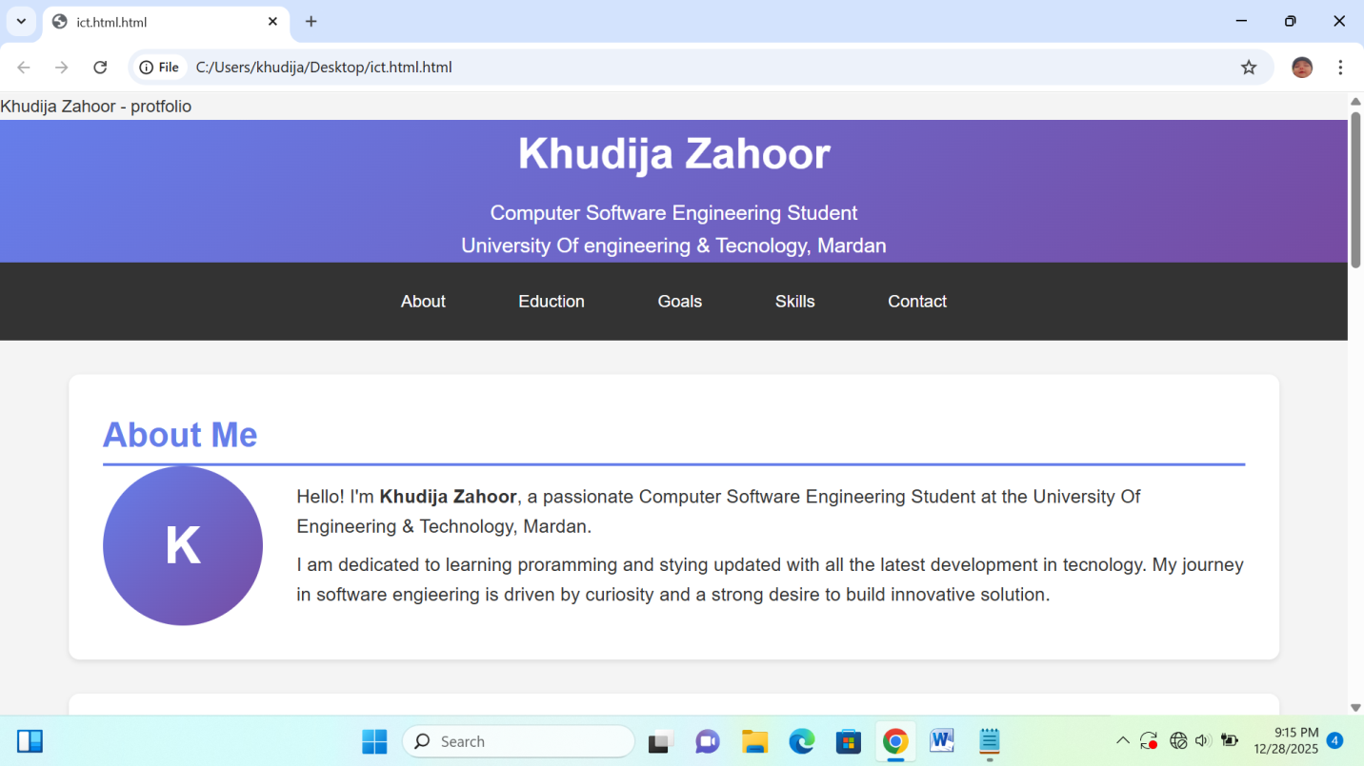
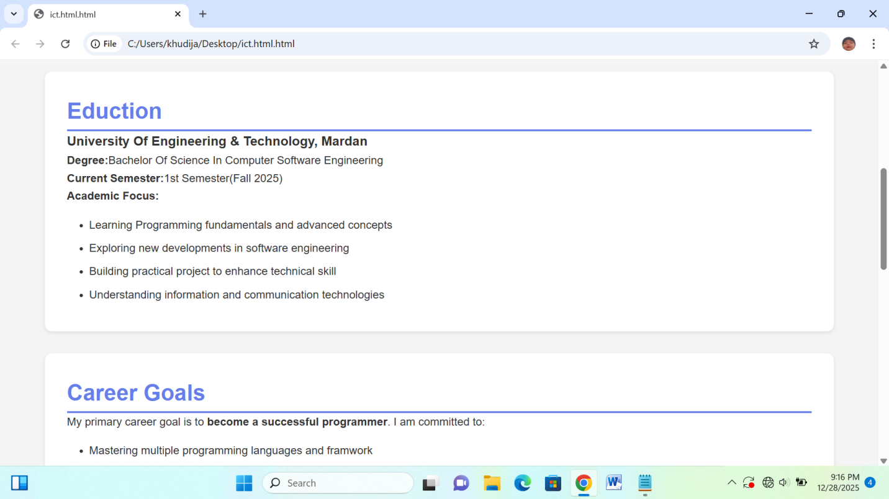
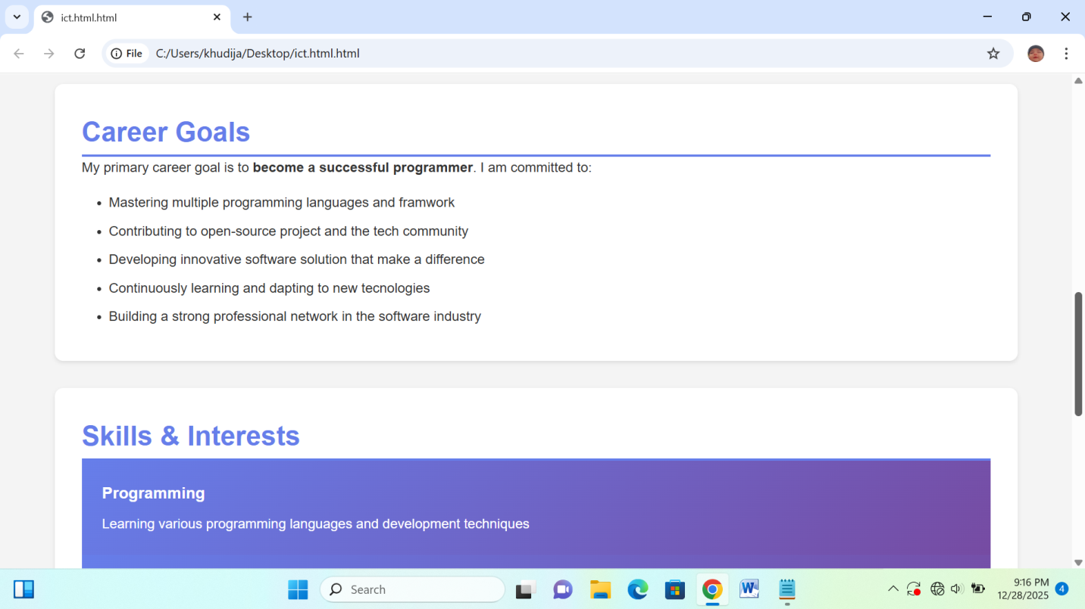
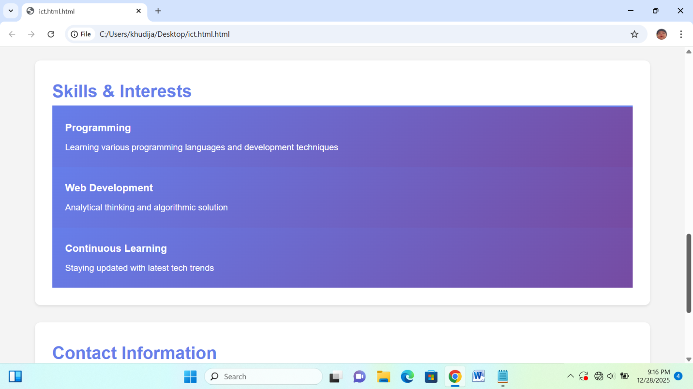
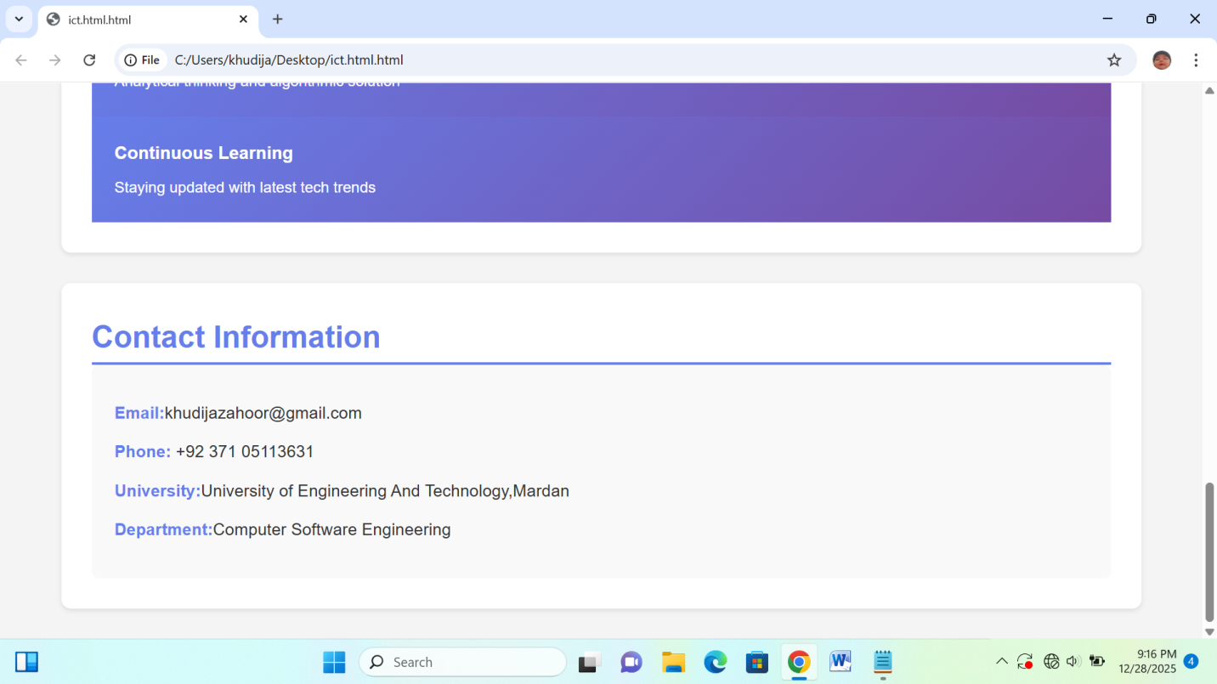
https://github.com/khudijazahoor321-dot/Information-and-Communication-Technology

